The Basics of Structure
NAME

１ Topic

２ Show a preview of issues. Issues are your main messages of presentation. Write 3 or 4 issues down.
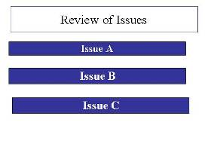
３ Focus on your issues at the top, and give supporting details（for example, facts, examples, data, etc.）.

Issue A


Issue B

Supporting data, examples, charts and information etc.
supporting data, examples, charts and information etc.
Conclusion of issue A
Conclusion of issue B


Issue C
supporting data, examples, charts and information etc.

Conclusion of issue C

４ Communication Design
- 1 minute for a power point slide.
- Simplify your issues.
- Show recommendations directly.
- Use suitable visual information as examples. ex) results of questionnaires
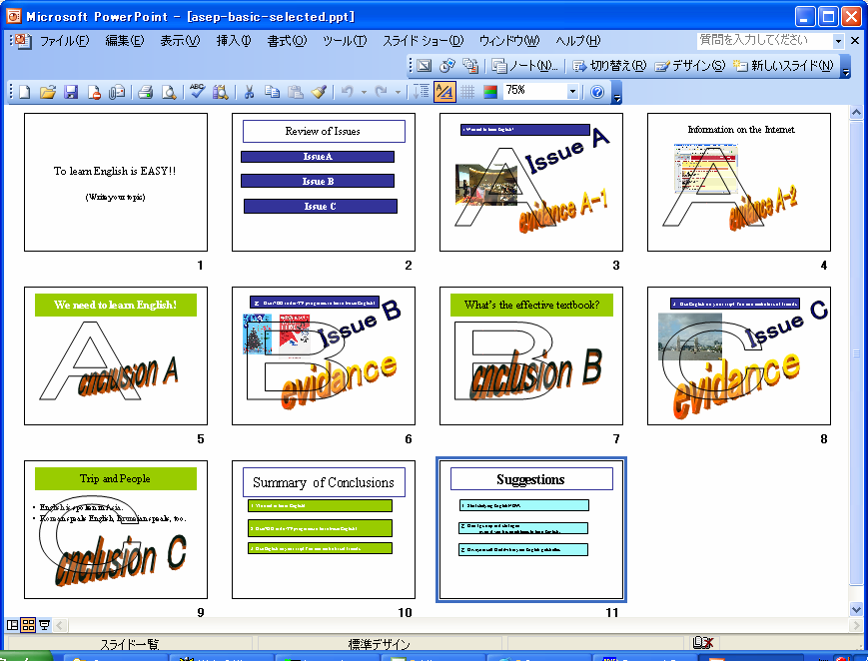

５ Tips for Presentation
- “Imagine” your presentation by using a concept map.
It is important to put information into the right order.
- General Procedure:
1 giving a topic→show issues(A, B, C)
2→supporting example (Evidence) for issue A
3→conclusion of A
4→supporting examples (Evidence )for issue B
3→conclusion of B
5→following the same way in Issue C.
6 Confirm the summary of conclusion
7 Confirm the recommendations

６ Presentation skills
You need these elements below for an effective presentation.
- Keep in eye contacts with your audience.
- Find your supporters on the corners. Although not all the audience will support your opinions, there are supporters who look at you， listening to, nodding at your presentation.
- Be an actor during your presentation. ----Use variety in your speech.
- Ask questions to your audience.
- Be careful for your attitude toward presentation .you should not move the slide while you are talking.
- Use body language-- Your audience will watch your actions, not just your data.

For successful presentation: You need Conviction, Confidence and enthusiastic attitude!!!

